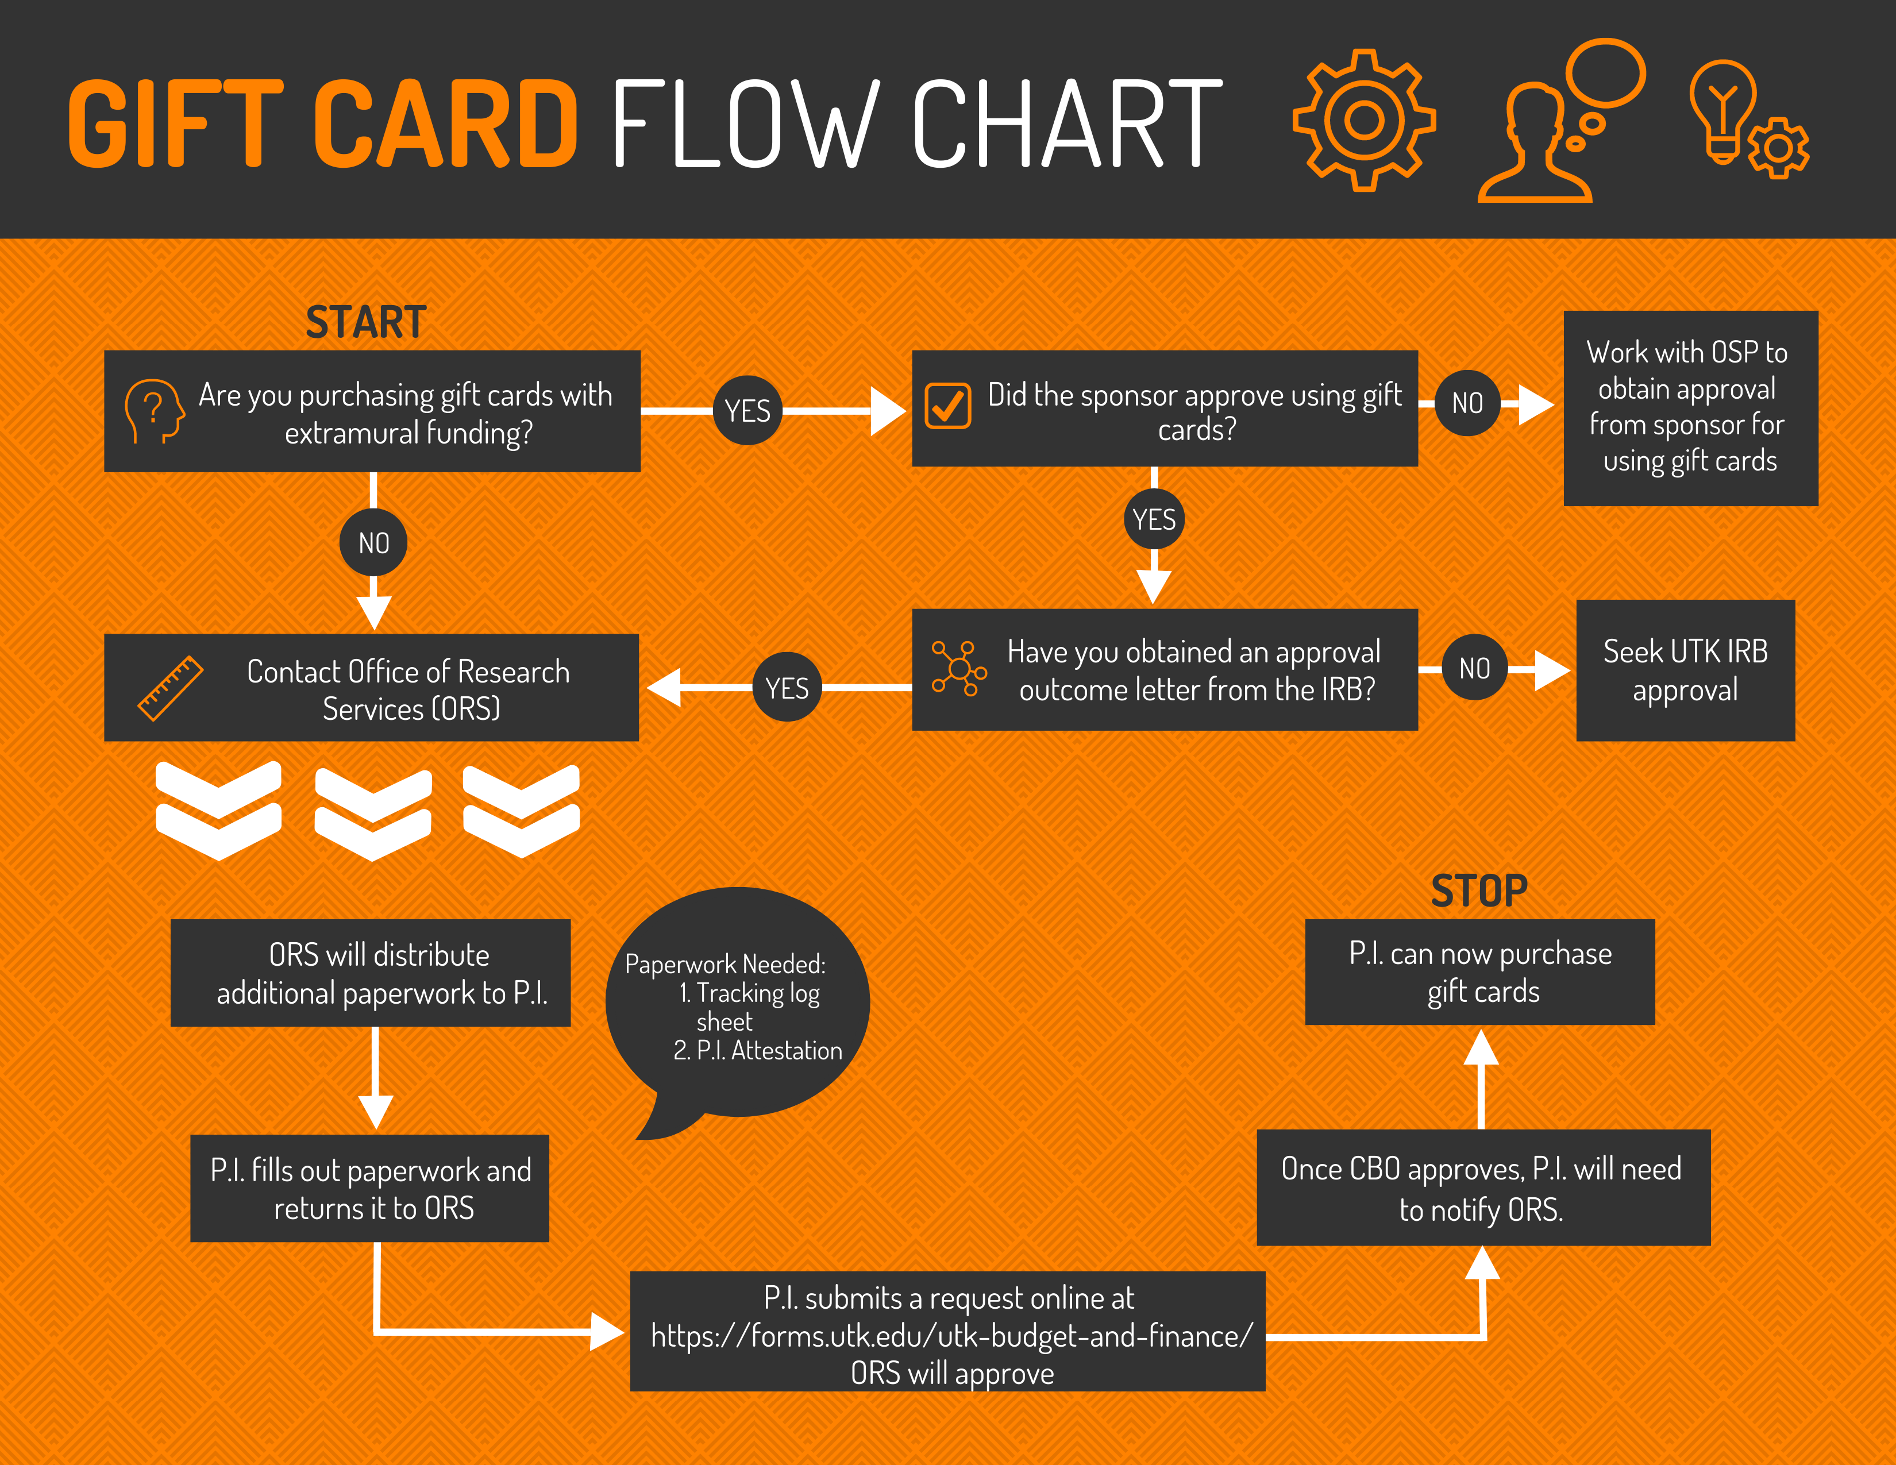
Purpose: The purpose of this procedure (SOP) is to provide implantation guidelines for the University of Tennessee Gift Card Policy http://policy.tennessee.edu/fiscal_policy/fi0313/
Abbreviations | Current ORS Personnel
CON: College of Nursing  ORS: Office of Research Services  ADR: Associate Dean for Research  PI: Principle Investigator  ORF: Order Request Form | Associate Dean of Research: Dr. Tami Wyatt  Director, Research Services: Nancy Taylor  Administrative Specialist: Holly Hauck
Introduction: Using gift cards as incentives or awards for externally funded sponsored project participants must be described in the grant proposal.
- All requests for gift card purchase must have Institutional Review Board approval prior to the purchase.
- All gift cards must be approved by the ORS prior to the purchase.
- If the gift card was not described in the grant proposal, the purchase of a gift card on a sponsored project requires prior written approval from the sponsor.
All Purchases for gift cards MUST be Pre-Approved by the Chief Business Office (CBO)

Gift Card Purchasing Procedure
- Request Gift Cards Online
  - UTK – Budget and Finance | Form Central
- Request no more than 3 months of cards at a time
- If requesting CBO to purchase Amazon gift cards this will be done after submission is approved
  - Make sure to attach IRB approval outcome letter
  - Add project R# to form
  - Online form will automatically come to ORS for approval first
  - UTK CON Gift Card Tracking Participant Log
- PI purchases gift cards via petty cash or through CBO for Amazon
  - PI can also direct bill through the UT Bookstore
  - We strongly recommend you only purchase the amount of gift cards you need right away to prevent unused gift cards at the end of the grant.
- PI provides Finance and Administration office with a Petty Cash Reimbursement form, all receipts from the gift card purchase and the CBO approval form.
- All cards must be used prior to end of grant. Any un-used gift cards are to be returned to the ORS
NOTE ***** Sponsored projects CANNOT be charged for unused gift cards

Paying for Gift Cards
- Gift cards may be purchased by a researcher and reimbursed through petty cash.
  - F&A requires a minimum of 7 days for turnaround
  - The PI may purchase gift cards, using the petty cash process, only after IRB, ORS and CB approval.
- CBO can purchase Amazon gift cards and can be requested after approval comes through
- Bookstore can do a direct bill to the research grant
NOTE *** Procurement cards CANNOT be used for the purchasing of gift cards.

Forms Required for Approval
- PI Gift Card Policy Adherence Attestation
- Gift Cart Online Request Form
- UTK College of Nursing Gift Card Tracking Participant Log

At the end of each Fiscal Year you must provide a list of unused Gift Cards for UTK internal audit.

